Flowchart for printing a food receipt:

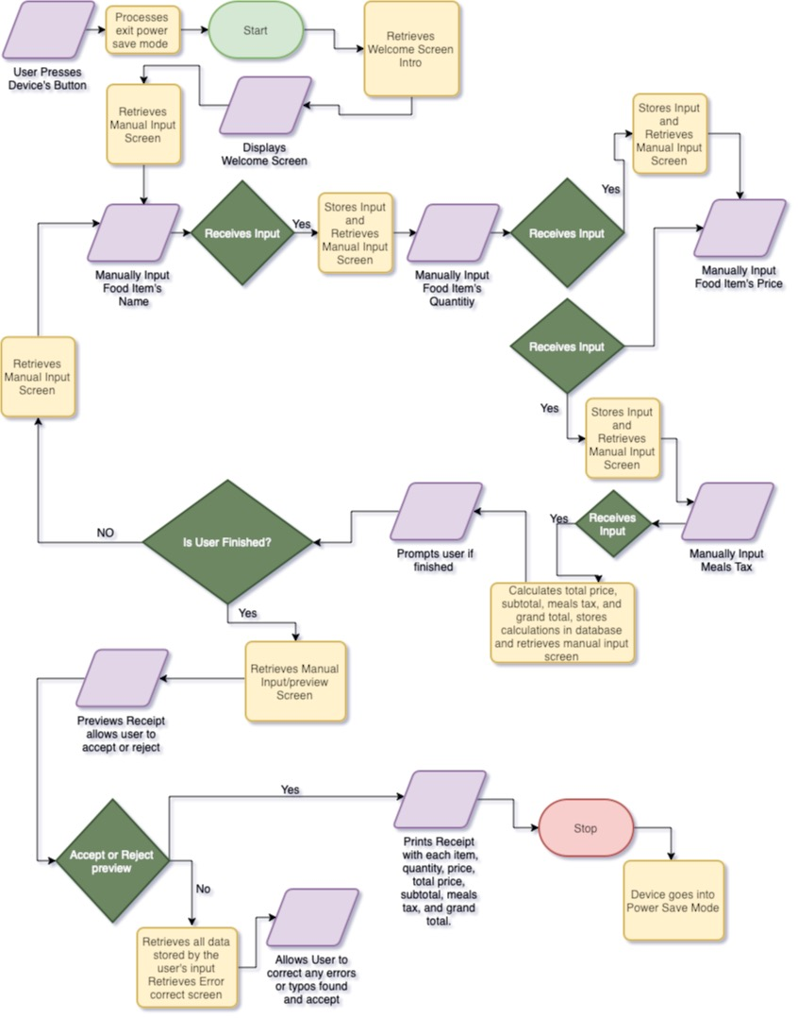

Pseudocode: ‘Painting a Wall’

Prompt User inputs for the height and width

Calculate the area based on the user input

Print the output

Store gallons of paint in a variable

Calculate paint needed to paint the wall

Print the output

Calculate the number of 1-gallon cans needed to paint the wall and round up

Print the output

Prompt user inputs for a color they want to paint the wall

Calculate total cost based on user input

Print the output

Value in producing pseudocode and flowcharts:

I believe that the Pseudocode was easier to construct, however both are essential for complete understanding. Some of the challenges, I faced when producing flowcharts was deciphering between inputs and decisions, I wanted to naturally combine the two. When we skip the creation of pseudocode and flowcharts the understanding of what the end user wants to achieve can be lost in translation. Personally, when I was completing the flowchart and pseudocode, I gained great insight on how to increase my creative and comprehension output.